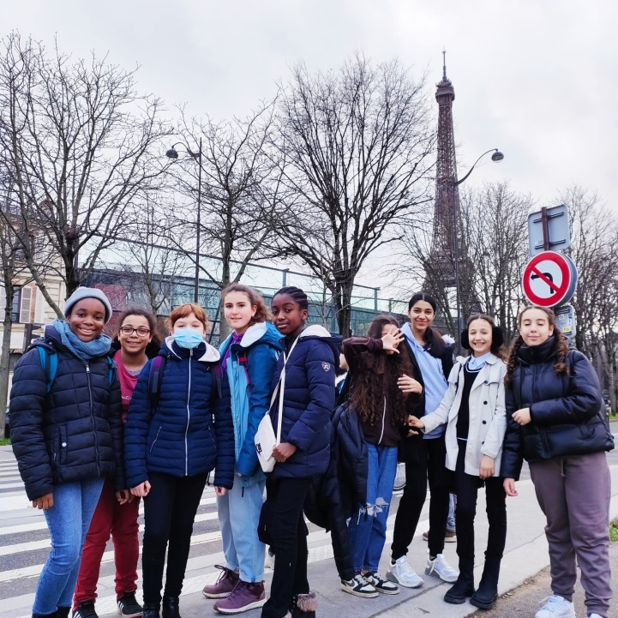

On Friday, 6th January we went to Paris on a school outing.

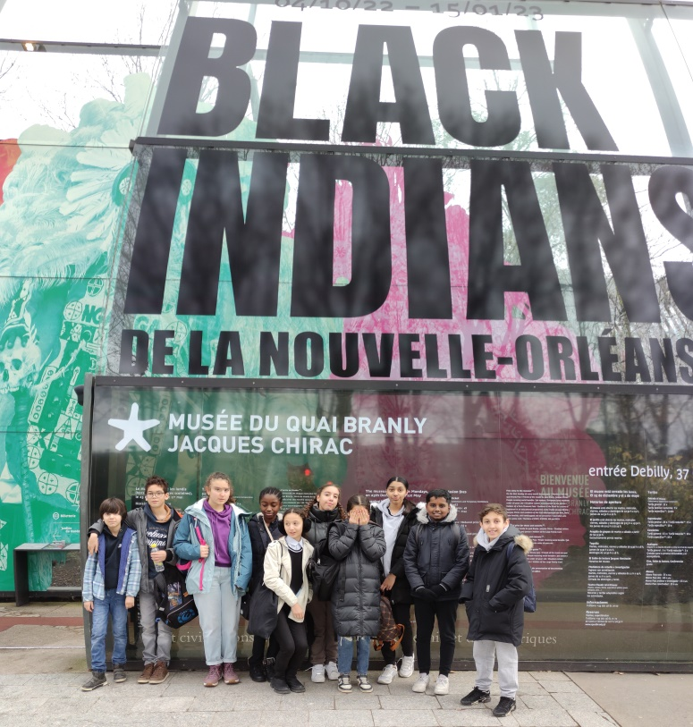

We visited an exhibition intitled « Black Indians from New Orleans » at the Jacques Chirac, Quay Branly Museum .

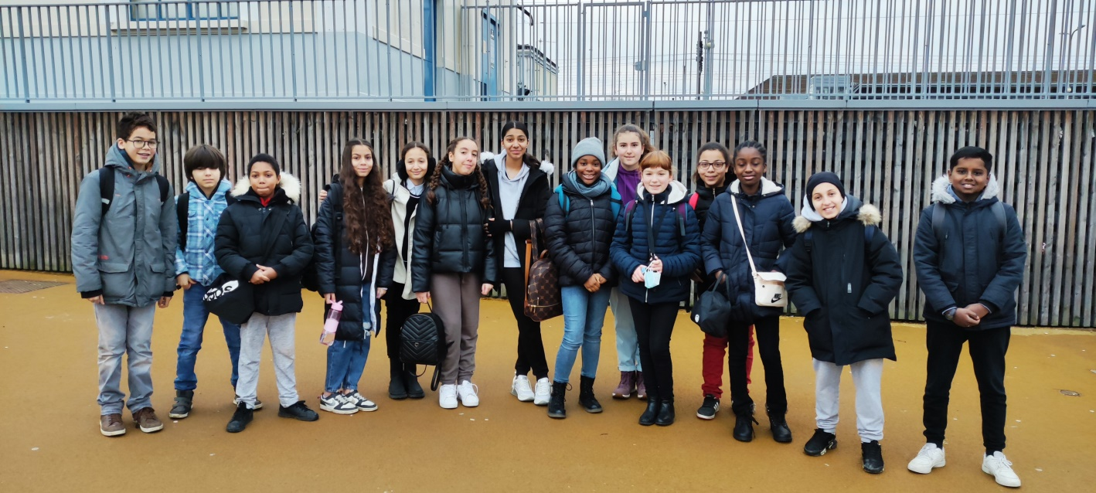

We took the train in the morning and the French « tube » to get there.

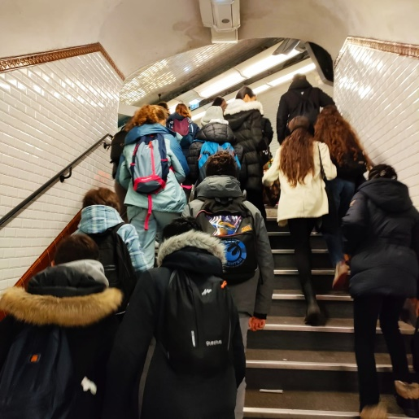

|  |  |  |
| --- | --- | --- |
| C:\Users\pmarques\AppData\Local\Microsoft\Windows\INetCache\Content.Word\1673260432438.jpg | C:\Users\pmarques\AppData\Local\Temp\Temp1_sortie.zip\1673260432447.jpg | \\SRV-0771761W\pmarques$\Downloads\1673262447615.jpg |

We saw a lot of gorgeous traditional costumes. Black people wear them during the Carnival which takes place in the street of New Orleans, in Louisiana.

We had a great time !